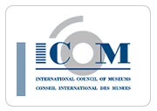
Daniel Castro, Stella Chryssoulaki, Jenni Fuchs, Pino Monaco, Marie-Clarté O’Neill, Umebe Onyejekwe
Silvia Ciriello, Colette Dufresne-Tassé, Nicole Gesché-Koning, Sonia Guarita do Amaral, Ayumu Ota, Arja van Veldhuizen
The International Board
Emma Nardi Chair
Josée Duhaime Secretary

Minutes - General Assembly CECA 2012
Yerevan, Armenia
Tuesday, October 23rd, 9am

Membership: 47 participants
1. Opening
Agenda
The agenda is accepted.

Minutes of the General Assembly 2011 – Zagreb
The minutes are accepted.

2. Reports
The reports were presented in point by point. The complete reports are to be found on the website, on the members’ section.

- President’s Report– Emma Nardi
- Relationships with ICOM
        - ICOM General Assembly, 4 – 6 June 2012
        - International Committees meeting
        - Feed back on the annual report
        - How to facilitate ICOM members’ inscription to Ics.
- General Criteria
Emma also reiterated the criteria that guided the board while choosing the projects and the ways to spend the budget.
        - Usefulness
        - Involvement
        - Transparency

  - Secretary’s report – Josée Duhaime
- Membership
1 393 individuals
- Countries
An increase of 16.6%

- Treasurer’s report – Josée Duhaime
The full annual account for the year 2012 and the provisional budget for the year 2013 are on the website, on the members’ section.

- Regional Reports
  - Europe - Marie-Clarté O’Neill
- Reactions of Europe National Correspondents
- Less staff
- More work
- Less direct money
- Nevertheless
          - Demand for training more than just information
          - A good participation to the CECA Best Practice Award

  - North America - Pino Monaco
1) Restructure of US/ICOM with separation from the American Alliance of Museums
2) New strategic plan and pilot of the new ICOM/IC membership joining/renewing processes
3) CECA Canada/USA members participated in the past issue of ICOM Education

  - Latin America and the Carribean - Daniel Castro
- 8th Regional encounter in Quito (Ecuador)
- Training course about research in Argentina (Colette Dufresne-Tassé)
- Seven countries connected through the Goethe Institut project (Colombia, Chile, Argentina, Bolivia, Peru, Ecuador, Uruguay)

  - Africa - Umebe N. Onyejekwe
- Very successful exchange between Nigeria and Brazil
- African Newsletter (issue 1 and 2)
- A CECA member from Tanzania won the CECA BP Award

  - Asia and the Pacific - Ayumu Ota
- Establish a network among members and appoint national correspondents
- First ICOM CECA Asia Pacific Regional Meeting The possibilities of museum education, Chiba, Japan, National Museum of Japanese History, 30Th November - !st December 2012

3. Special Project’s Reports
Again the complete versions of those reports will be found on the website in the members’ section

- Best practice
(http://ceca.icom.museum/node/209?language=fr)
- 27 projects
- An international and independent jury
- A publication
- New edition in 2013: comments to be addressed to Marie-Clarté O’Neill (carneill@noos.fr)

- Professional development
- Experience exchange ( http://ceca.icom.museum/node/6 )
We encourage you to fill in your member’s profile on the website, in the member’s section.
- Preconference workshops

- Web
- Addition of a huge amount of content on the website in 2012. (Videos from Zagreb, Best Practice Book, Icom education). More than 3000 pages!
- Website translation – In 2013, complete the ietms still to be translated on the CECA website.

- Pictures: The Board would really like to add pictures to the website but we need the members’ contribution. If you wish to share the pictures of events or activities held by CECA, please send them to Jenni Fuchs at icomceca@gmail.com

- Log in
(http://ceca.icom.museum/user)
Any member wanting to register on the members’ section of the CECA website has to first go to the website and find out if they are registered already.

What to do if:
A member has forgotten the log-in detail
A member doesn’t know if he has registered
Send a message to Jenni Fuchs at icomceca@gmail.com
Mention clearly your need.

- Research Network
Two points were mentioned:
- Research initiation workshop in Argentina with 18 professionnals, Buenos Aires, April 2011.
- Researcher’s network is composed of 63 researchers from museums and universities

- ICOM Education
The issue ICOM Education 23-Museum education and new media was presented in the absence of Stella Chryssoulaki. Emma thanks her warmly for the work done and for the publication of this edition.
(http://ceca.icom.museum/node/203)

- ICOM CECA World News
- Two issues: december 2011; June 2012
- Downloadable from CECA website (http://ceca.icom.museum/node/239)

- CECA CLUB

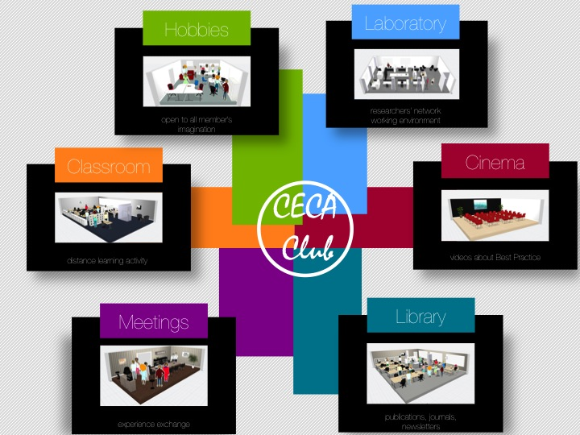

The slide is only a first draft that helped the board to discuss the project. The Board wants to increase the involvement of the members and usefulness of the website. This is why we want to offer all members the following facilities that will be organised exclusively for them as an added value their membership.

- Publication - Only a part of them will be open to the general public.
- Cinema - Where videos can be watched and downloaded.
- Laboratory - Where the researchers’ network can publish the results of the activities they want to share with the members.
- Meeting room - Where members will find all the information about the experience exchange, updating their form and reading other colleagues’ profile.
- Classroom - Where distance self-training activity will be organised. The first topic of the classroom will be the Best Practice document.
- Just for fun - Where member can find stories and pictures related to museums which show a funny side.

The CECA Board discussed which name would be more appropriate for the activity and decided to submit the question to the GA, in order to avoid any inter-cultural misunderstanding. After a lively discussion, the GA adopted the name CECA e-World.

4. Elections 2013
- Improvement of the voting system
- The process starts in January 2013
- Check the web for deadlines
- Apply for the positions and encourage other CECA members to do it.
Action: We need to know the rules concerning the institutional member. How many members from the same instution can vote at an election.

5. Next Conferences
2013 - Rio de Janeiro
Magaly Cabral presented the next conference in Rio de Janeiro.
Dates: 10th to 17th of August 2013
Theme: Museums (Memory + Creativity = Social Change
2014 – Alexandria, Nicole Gesché Koning

6. Any comments/issues from the membership

- Hadwig Kraeutler wants to add a link for the Memorial held in Vienna.
Action: Hadwig will send the information to Jenni Fuchs (info@jennifuchs.com )

- The process of registration is very difficult and not straightforward. Members do not know if they are members of CECA or not.
  - They never get a confirmation of their membership.
  - They do not know who to address their question to.
  - There is a need to formalise the registration of an international committee through ICOM.
  - Action:
1) formal: Emma writes a letter to ICOM about the problems our members reported to us (during this meeting and in general)
2) informal: every member writes to Josée whenever he/she has a problem with membership procedures. Josée will contact ICOM Paris to get problems solved.

- The CECA Board’s approach of adding the reports on the website is a problem for African countries that don’t have access to internet. Paper copies are still the best way to inform the members.

- Member’s information about the General Assembly.
  - The information about the General Assembly never got to the members. Or some members never got the e-mail prepared by Emma, forwarded by Josée to the regional coordinators. They were not prepared for the GA. They had not read the documents.
  - Action: Review our procedures to inform the members making sure that the important messages get sent and received.
Emma and Josée will write to members directly and the RCs will reinforce the message.

End of Session

