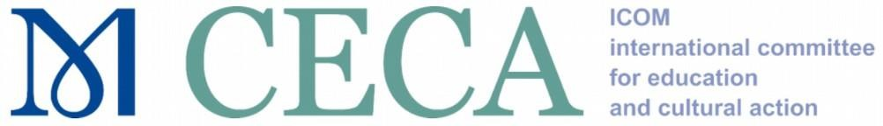

CALL FOR APPLICATIONS 2024

Grants to help members participate in the annual conference of CECA 2024
Application

Section 1 - Information about the applicant

Museum/Institution | Here
City | Here
Country | Here
Program presenter
First Name | Here
Family Name | Here
Contacts | Professional e-mail address:  Here  Personal e-mail address:  Here
 | Phone number: Here
CECA member:
Tick where appropriate
ICOM Card Number | Here

You must attach to this Application: 1) Digitized photocopy of the ICOM card with the 2024 sticker. 2) Digitized receipt of the payment of the 2024 annual fee or certificate from the national ICOM.
VERIFY that you appear as a member of CECA in ICOM's records.

Section 2 - Information about the program

Title of the program | Here
Abstract of the program  (max 200 words) | Here
Description of the program according to the Best Practice  document | - Conceiving and planning of the program, in particular the following points: objectives, relevance and justification, resources, collaborations, contents and mediation tools (max 850 words)  Here
- Carrying out the program, in particular the following points:
planning, implementation. (max 350 words)

Here
- Evaluation and remedial process, in particular the following points: accompanying studies, studies for the evaluation of the results, remediation (max 250 words)

Here
Please save this form with your surname and first name when sending it to us.
Ex. SMITH, Robert (.docs)
Thanks you!

